Student

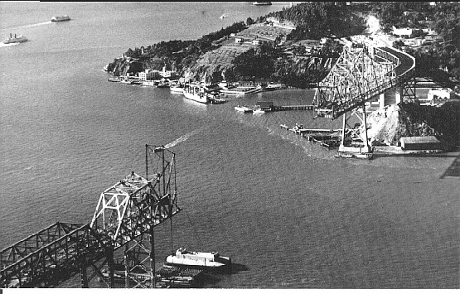
Workbook

Student Name:

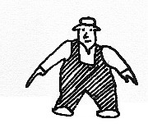
Student Number:

Teacher:

Class:

Bridge Building Competition Brief:
You are to construct a bridge using plywood as described below. The bridge can be modelled on any natural or built structure and must meet the following specifications:
- The mass of the bridge (and the base material) is to be as small as possible.
- The internal width of the bridge is to be not less than 100 mm.
- The bridge is to consist of a single span of one metre.
- The bridge is to have the highest structural efficiency (E).
E = LOAD (supported in grams) / MASS (of the bridge)
E = L/M
The maximum Load is to be 25kg.

Materials - Any plywood may be used from the following list:
9.5 mm, 6 mm, 4 mm, 3mm,
2 mm bending ply
1 mm veneer
PVA wood adhesive or hot melt glue may be used.
Other materials may be used provided justification is given to teacher prior to commencement of the project.

Process:
Any process, that will suit the properties of the material, may be used in the construction of the bridge.

Testing:
Testing will be conducted in week 10 during the lunch break in the school hall.
The bridge is to be tested with a load of 25 kilograms placed at the centre of the span (without failure).
Provision must be made for a steel plate to be placed at the centre of the structure to apply the LOAD.

Assessment criteria
Criterion |  | 6 | 5 | 4 | 3 | 2
1 | Quality of production
2 | Test efficiency (E)
3 | Design and engineering calculations  And sketches
4 | Data & Properties of plywood

RESEARCHING PLYWOOD CHARACTERISTICS
In the space provided below sketch and notate some of the important facts that you have discovered in researching about the characteristics of plywood, like the example shown below (attach extra pages if you need them.

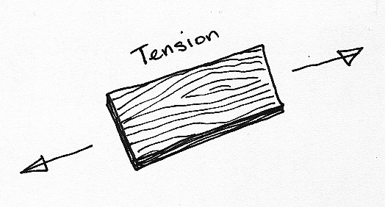
Plywood is stronger in tension when a force is applied parallel to the grain rather than perpendicular to the face grain. This is because generally ply contains odd numbers of laminations that are predominantly parallel to the face grain.

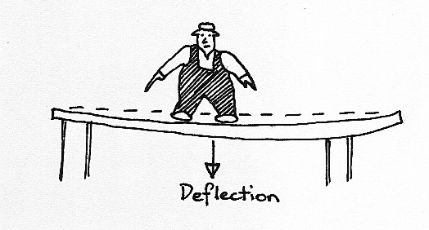
RESEARCHING STRONG SHAPES
First goal for building a bridge is to try and limit the amount of deflection that it has. Deflection places additional stresses on the bridge structure. Below sketch and notate some strong shapes that you found in your research

There are different types of bridges all around the world. Listed here are the five most common types. From your research, sketch or paste in some more examples of bridge designs that you have seen (from internet, magazines and books).

RESEARCHING TYPES OF BRIDGES
Cantilever
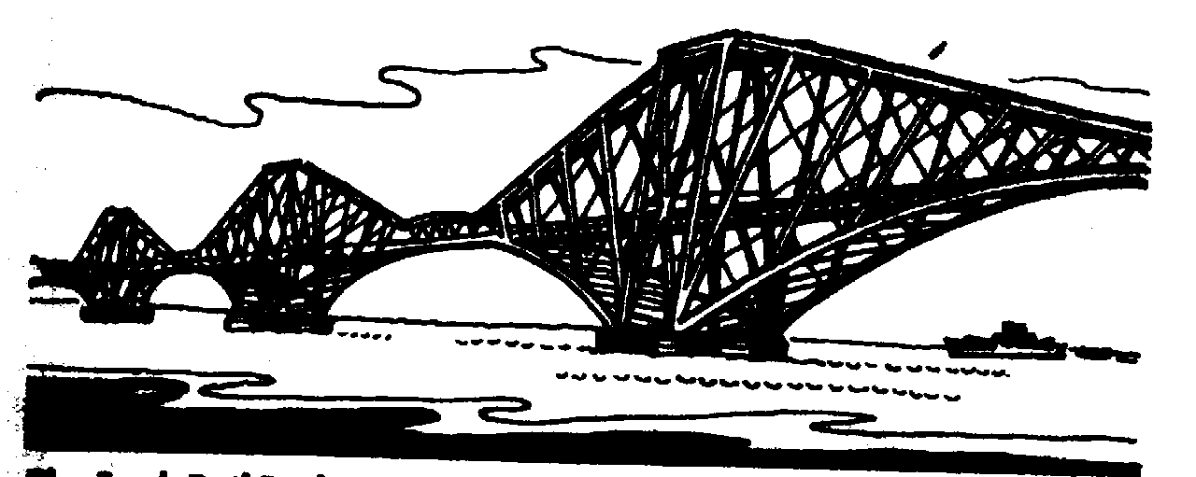

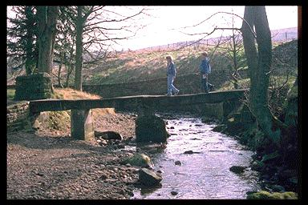
Beam

Suspension
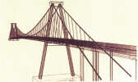

Arch
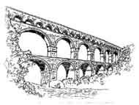

Truss
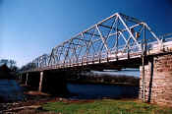

In the space provided draw up your design ideas. Remember to include notes on features of the design. A list of pro’s and con’s are always a good idea too.

DESIGN IDEAS-Creations

Concept 1
Remember that there is nothing more dangerous than an idea if it’s the only one you have!! So let me see some more ideas!!

DESIGN IDEATIONS

Concept 2
This is where you show me what you are going to make. Remember to show details of your bridge design with extra sketches and notes of explanation. With this design I want you to also provide justification in choosing this design

DESIGN IDEATIONS

Chosen Design
In this space I want you to draw a dimensioned working drawing with materials list. Don’t panic we will be doing this in class.

WORKING DRAWINGS

This section is where you show me that you know what is involved in making your bridge. In the oval provided, sketch the process and then note beside it what is happening. Like the example shown below.

SEQUENCE SKETCHING
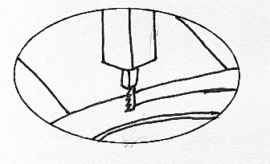

Stage 1. Cut out shapes on the Bandsaw, keeping as close as possible to the waste side of the line.

Stage 2.

Stage 3.

Stage 4.

Stage 5.

Stage 6.

SEQUENCE SKETCHING CONTINUED

Stage 7.

Stage 8.

Stage 9.

Stage 10.

Stage 11.

Stage 12.

If you need more pages than I have provided you can add them in if you wish.

In the following table is a risk assessment of the possible machines that you might need to use. Fill out like the example shown.

MACHINE USAGE & SAFTEY

Machine Item | Hazards | Risks | Competence | Risk Control
BAND SAW | Electricity  Rotating Blades | Medium, level Risk – Be aware that I can cut my fingers off. | LOW | Ensure that the Teacher is with me whilst I use this machine

After the whole process of building the bridge and testing it, answer the following questions about what you learned from the bridge construction competition

SELF EVALUATION

- How well did the final bridge do during testing, did it hold 25kg? How much weight did it hold? What was it’s efficiency? What was the best efficiency in the class?

- What improvements could I have made to my bridge to make it better?

- How did the brief influence my type of design?

- What changes did I make during the manufacturing process?

- How did my research influence my design of bridge?

- What have I learned from this process of designing bridges?

- What other bridges did I like?

