Unit of Work to Suit the Industrial Technology and Design Subject Area Syllabus and Guide Lines
BRIDGE

C O N S T R U C T I O N

Time Allocation:
22 ½ hours to include 7 ½ hours of student personal time (one term)
Student Year Target Group:

Year 10
Syllabus Focus Area:
Industrial Technology and Design – Subject area syllabus:
Product Design Strand: PDM 5.1; PDM 5.4; PDM 5.6; and PDM 5.7 (Sc NPM 5.3)
Graphical Communications Strand: GC 5.1; and GC 5.2
Industrial Systems and Control Strand: IS & C 5.5; and IS & C 5.6
KLA Technology Years 1 – 10 Subject Area Syllabus:
Technology Practice Strand: PI 5; PD5; PP5; and PE5
Context for Student Learning Activities:
Traditional woodwork shop, graphics lab and Internet access is all that is required for Unit of Work. Materials used for the project consist of various thicknesses of plywood and PVA glue.

Prior Experience Required:
It is assumed that students have little prior experience to the Design, Make and Appraise principles that are generic to Industrial Technology and Design Subject Area. It is assumed that the students have prior learning experiences in the following areas:
1) Graphical Communication that has developed the students understanding of sketching and working drawings.
2) Basic woodworking skills and understanding of machines in workshop.

Introduction
This unit of work is aimed at year 10 students in a junior secondary education school environment. The unit is designed so that it can be taught in the tradition Manual Arts workshops. The Shop ‘A’ workshop would be most conducive to equipping students with the most appropriate types of machinery. In conceptualising this unit it was envisaged that students would be provided with ample opportunities to conduct research through Internet access, library books and develop their designs and folio in the graphical communication rooms.

Time Frame
This unit of work is expected to be over a period of one term, with an expected contact time of 22 ½ hours within the school classroom. The students will be provided 3 x 45 minute periods; 1x 45 single period and 2 x 45 double periods. In addition it is expected that students will be engaged in 7 ½ hours of work external from the normal classroom activities. Ample provision will be made in this unit of work for students “at risk” to complete the set tasks within school hours.

Prior experience
This unit of work is designed to be towards the end stages of year 10 and students should have had learning experiences from their year 8 and 9 programs as follows:
- Intermediate units of work in the design process
- Understanding of graphics’ from previous units of design process
- Understanding and experience in using basic fixed woodworking machinery
It is envisaged that projects like the bridge building unit is a stepping stone for students to progress toward senior school Technology Studies.

The Teachers Role
It is expected that this project would motivate the students intrinsically, yet it is also understood that a possible large theory content might seem overwhelming to the students. With this in mind some suggestions to continue the student motivation include building up the anticipation of testing day in some or all of the following suggest ways:
- Challenge the students to try and build a better and tougher bridge than the one that you are building, yes that is right they love to beat the teacher!
- Organise for the testing day to be in the school hall during the lunch hour or at schools expo day, great PR for the subject area as well.
- Have a trophy on display for the ‘winning bridge’. This could be inaugural and made by the technology department or brought from your local trophy shop…either way it will work (so long as you don’t win).
The ‘theory’ of doing a design brief requires you as the teacher to facilitate the students in their designs; this is a hard task to start with, with highly rewarding results at the end of the project, as students concepts and ‘ideas’ are realised.

Organisation
Management of the learning environment/s will proceed according to student progress and interests. Students will take an active role in the learning process and progress as well as the assessment of their learning. Folio development and presentation will play a key role in capturing the student progress during the unit of work.

Aims and Objectives of this Unit
- Expansion of each students D.M.A. skills and experiences
- Participation in and the development of a safe learning environment
- Students will use terminology relative to a particular field of expertise
- The provision of opportunities for using information technology as part of the project construction
- Have the student progress further into becoming a life long learner

Learning experiences gained from this unit
- Working within a closed design brief
- Developing design folios to promote their ideas and show processes
- Working with different materials and tools; how to select and use them appropriately for specific purposes
- Producing objects that correspond with a design brief
- Project that encourages student self evaluation
- Development of safe working practice through risk assessment and hands on experiences with machines and hand tools
- Application of learned graphical skills into a practical application

Assessment

This unit will look at student assessment in regards to three different facets:

Diagnostic assessment: Students will show prior knowledge when ideating in their brief about machine safety, processes of construction and during discussion with the student during the classroom activities.
Formative assessment: This happens during the classroom activities; where students are questioned during general discussion, observations of students working and student self-evaluation of their progress.
Summative assessment: This form of assessment is evaluated in the culmination of the student workbook and the testing of the students’ bridges, in relationship to the criteria. Students also participate in a self-evaluation form (last page of design brief) to give an indication of how the entire unit went for each individual student.

Materials required for the project
  - Sheets of 2400 x 1200 plywood in the following thicknesses:
9.5mm, 6mm, 4mm and 3mm ply
2mm bendy ply
1mm veneer
  - PVA glue for gluing the bridges together
  - Masking tape for clamping of bridges
  - Two benches 1000mm apart (you need a student on each corner of the bench to stop the bridge levering the bench off the ground)
  - Large steel bucket
  - Weights and steel bar to test bridge efficiency
  - Set of digital scales to weigh bridges and weights
  - Weight hanger to attach the bucket to the bridge (see detail below)
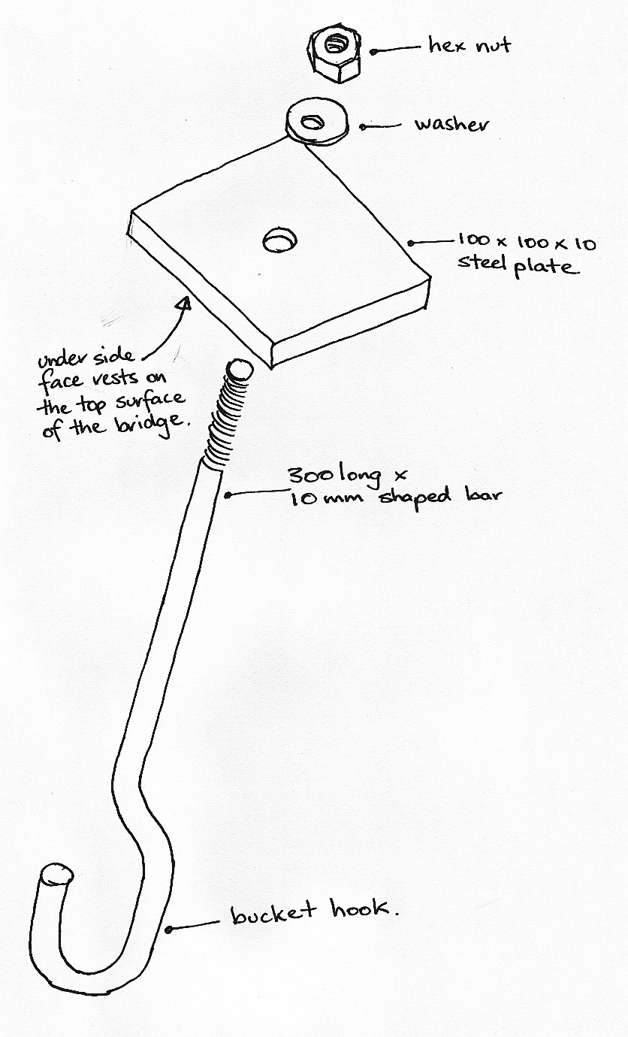

Resources

Internet sites that are worth while book marking in regards to Bridges

http://encarta.msn.com/index/conciseindex/25/concise.asp?mod=1&ti=761561057
http://www.discovery.com/stories/technology/buildings/bridges.html
http://www.iit.edu/~hsbridge/database/search.cgi/:/public/international/current/international_rules
http://www.buildingtechnology.com/bcba/bridges/basics.htm
http://www.iit.edu/~hsbridge/database/search.cgi/:/public/index
http://members.tripod.com/mrlewisclassroom/bridgedesign.htm
http://pghbridges.com/
http://www.pbs.org/wgbh/nova/bridge/
http://www.ndrs.org/physicsonline/bb-menu.html
http://www.bardaglea.org.uk/bridges/welcome.html
http://bellnet.tamu.edu/res_grid/trussb/designs.htm
http://www.ktca.org/newtons/12/bridges.html

Internet sites that are worthwhile book marking in regards to Plywood

http://home.vicnet.net.au/~woodlink/woodlink.htm
http://oak.arch.utas.edu.au/tech/ply.html

Video on Bridge Design (Shows students in a competition)
Science 55 Videotape: The Brunel Experience 1: The great divide: Building a Bridge.

Books about bridges.

Bull, R. (1989). Starting design and Technology – Structures. London, Bath Press.
Burns, M. (1982). Math for smarty-pants. Boston: Little, Brown and Company.
Clarke, D. (Ed.) (1979). The encyclopaedia of how it's built. New York: A & W Publishers, Inc.
Corbett, S. (1978). Bridges. New York: Four Winds Press.
Dixon, M. (1990). Structures. Turin, Canale.
Gaff, J. (1991). Tell me about building, bridges and tunnels. Spain, Kingfisher Books.
Lambert, M. (1991). Technology in action – Building technology. England, Wayland Publishers.
Oxlade, C. (1996). Super Structures. London, Belitha Press.
Spangenburg, R. (1991). The story of America's bridges. New York: Facts on File.
Stephens, J. (1976). Towers, bridges, and other structures. New York: Sterling Publishing Company.
Stix, G. (1993, Apr). Concrete solutions. Scientific American, pp. 102-112.
Whitney, C. (1983). Bridges. New York: Greenwich House.
Wollomir, R. (1994, Jan). Inside the lab and out, concrete is more than it's cracked
up to be. Smithsonian, pp. 22-31.

