How does a colour TV work?

A Cathode Ray tube.
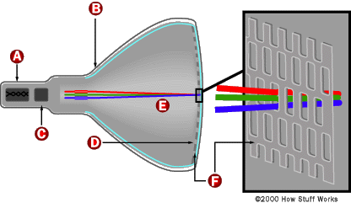


Inside a TV tube, a Cathode produces beams of electrons. There are three streams; red, blue and green. The streams can be spread out across the screen by being ‘steered’ by magnets. This allows them to hit all the parts of the screen.
The television was invented by John Logie Baird. He managed to broadcast a black and white picture in January 1926.

If a picture is made up of small dots, very close together. The brain can form them into an image. Artists like Seurat and Signac used this style to produce large paintings.
Thanks to: nottinghamschools.co.uk

The back of a TV screen.

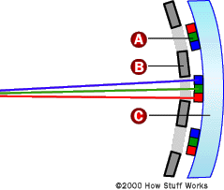


You can make any colour you wish from just 3 different colours of light. By changing the amount of red, green and blue light, and by altering the brightness of those colours, we can see different shades.

The back of a TV screen is covered with dots of phosphor. The dots are arranged in groups so you always have a red, green and blue dot together.

Phosphor is a chemical that gives off light when it is hit by electrons. There are many different colours of phosphor, but just three are used to cover the inside of a TV screen with small dots. They are red, green and blue
Keywords

Cathode
Phosphor
Electron
Conductive

When the magnets break in a Cathode Ray tube you only get a dot of light in the centre of the screen.

The shadow mask in a screen stops the light from the phosphor from shining inside the Cathode ray tube. If it did we would not see a clear picture.
Thanks to: nottinghamschools.co.uk

nottinghamschools.co.uk/

