This section is from the book "Clothing And Health. An Elementary Textbook Of Home Making", by Helen Kinne. Also available from Amazon: Clothing And Health.

How Cotton Cloth Is Woven
Not long ago we learned how the cotton plant furnishes us with cotton for clothing. There are many people who help in changing the cotton from fiber to cloth. While you are waiting for the cotton material and the pattern, shall we study how cotton cloth is made?
Cotton is used for many things. We learned that cotton is shipped in bales of 500 pounds each from the United States to all parts of the world. The manufacturer receives it at the factory and changes it by many processes into what he wishes to sell. Some manufacturers make only cotton threads of various kinds, for sewing, knitting, and crocheting. Others make cotton cloth of one variety or of several varieties. We know there are many kinds manufactured. Others make absorbent cotton, gauze, and such things for surgical use for the sick. Some make hosiery, gloves, towels; and others make knitted underwear, or laces and embroideries. Others use cotton for war purposes, for guncotton. John Alden said he did not know that cotton is used for so many things.
The loom for weaving cotton. We have learned that cloth is made of threads which run lengthwise, called the warp threads, and of crosswise threads, called the filling or woof. The machine for holding the threads and doing the work is called a loom. What is the firm edge which is woven called? Look at Miss James' little loom (Fig. 38). It shows the warp, and the filling yarn as it passes over and under and makes the firm edge as it turns each trip back and forth around the edge threads. If you have never woven a piece of material, suppose you take a box cover and make a small loom. The picture (Fig. 39) shows one made at Pleasant Valley School. Did you ever see your grandmother weave on a loom? Look at the picture (Fig. 40) of a grandmother weaving on a cloth loom. It is not Grandmother Allen, although she knows how to weave. The warp threads are rolled up on a big roller at the back of the loom and are extended to the cloth roller at the front near where she sits. She holds the filling thread in her hand. It is wound on a bobbin which fits in the shuttle. She throws the shuttle from side to side and works her feet to alternate the warp threads, in order that the filling thread may go over and under, and make the cloth. Look at the shuttle in the picture (Fig. 41); it holds the bobbin of thread. There are many kinds of looms. To-day cloth is woven on looms run by machinery. It is much easier and quicker than working by hand, and so cotton cloth can be made more cheaply. Frank Allen says he saw a loom at the silk factory he visited. If it were not for machines, our clothes would cost much more than they do. Think of all the people who help to give us our cotton clothes, from the planter who sows the seed to the manufacturer whose men prepare and weave it. Have you ever visited a cloth factory and seen the many machines and heard the great buzzing noise which they make? It is a busy place. Some factories make only warp, or filling, yarns. They are called spinning factories or mills (Fig. 46). They send their product to the other manufacturers who have only weaving machines for making the yarns into cloth. It is about 130 years (1789) since the first cotton mill was started in the United States, and only a few years longer since the first mill was started in England. Before that time, people of different countries made their own looms according to the ways they thought out. As men felt the need of clothing to wear, they tried to make cloth; and we find all kinds of primitive looms as their invention. Can you look up the meaning of primitive? Notice the two pictures (Figs. 43 and 44) of primitive people weaving. The Indian girl is holding the shuttle in her right hand; the loom is fastened to something and is also attached at her belt. In that way the warp threads are held securely while she passes the filling back and forth. On page 136 you will find a picture (Fig. 81) of a Japanese girl weaving silk. Notice the loom; find the roller holding the warp yarn. Find the shuttle which she uses to throw the filling yarn. Can you tell where she rolls the cloth as it is woven? Under her elbows in the picture is a cloth roller on which she rolls up the woven cloth as she weaves and unrolls the warp from the warp roller. Isn't this a wonderful story? We have not yet learned how the cotton is made into the warp and filling ready to be woven. We shall save that part of the story for to-morrow. The Pleasant Valley girls and boys enjoyed this part of the story about cotton and are anxious for Miss James to tell some more.
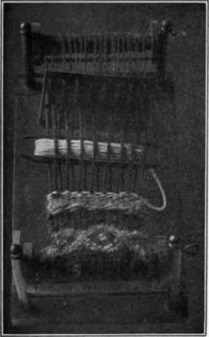
Fig. 38. - Miss James' little loom.
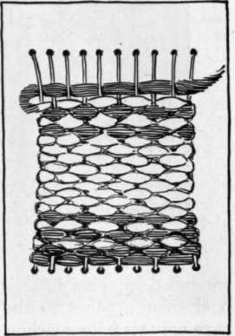
Fig. 39. - A small loom made from a box cover.
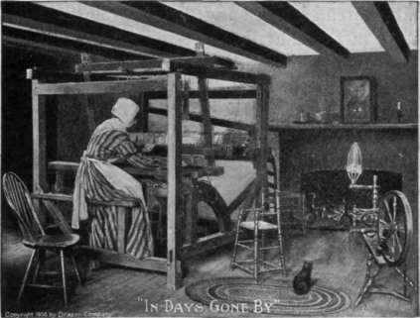
Courtesy of Draper Co., Hopedale, Mass. Fig. 40. - "In days gone by."

Fig. 41. - The shuttle holding the bobbin of yarn.

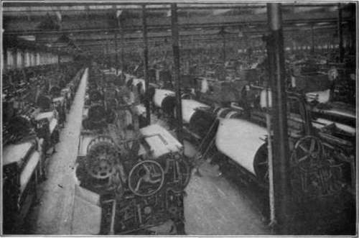
Courtesy of Draper Co., Hopedale, Mass.
Fig. 42. - A weaving room in a modern factory.
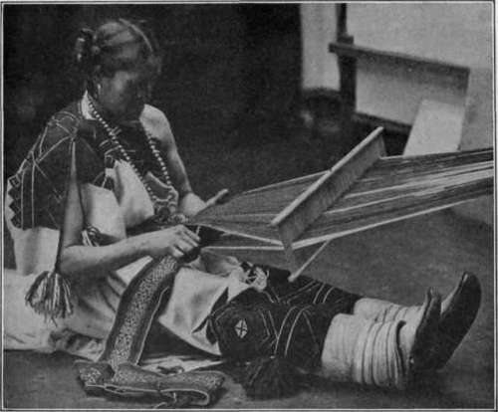
Courtesy of Smithsonian Institute, Bureau of American Ethnology. Fig. 43. - Indian girl weaving a belt by hand.
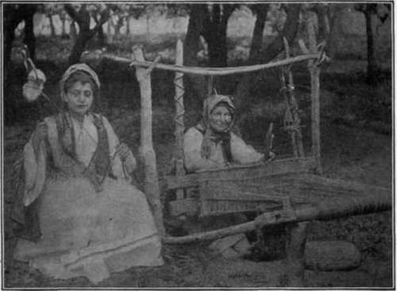
Fig. 44. - Another primitive loom and a girl spinning. The distaff with the wool for spinning is held under the girl's arm.

Exercises And Problems
1. Try to make a simple loom. Take a piece of cardboard 10 X 12 inches. Make a row of holes about 1/4 inch apart one inch from the top; another row 1/4 inch apart one inch from bottom. String the warp back and forth from hole to hole so it looks like the picture (Fig. 39). Weave a piece of cloth with the filling thread which goes over and under.
2. Visit a weaving factory if you can.
3. See if you can spin a piece of carded wool. Perhaps you can card some wool with the hand cards which your great grandmother used, as the Pleasant Valley girls did.
4. Try to collect pictures of spinning. The primitive peoples did this in different ways.

Continue to:
- prev: Lesson 2. Selecting Pattern And Cloth For Nightdress
- Table of Contents
- next: Lesson 4. The Spinning Of Cotton Into Yarn

