This section is from the book "Clothing And Health. An Elementary Textbook Of Home Making", by Helen Kinne. Also available from Amazon: Clothing And Health.

The Story Of The Manufacture Of Linen Yarn Into Cloth
To-day we are going to study again about our linen tablecloths and napkins, and learn how the flax fiber is made into cloth after it has been cleaned at the scutching mill.
Combing and spinning flax. Uncle John divided his story in two parts, and told the Pleasant Valley Girls' League about the manufacture of flax as well as about its growth. The scutched flax is delivered to the manufacturer. He must first spin the flax into yarn before it can be woven into cloth. The flax fibers measure from 20 to 35 inches in length. How are they to be made into one continuous piece for spinning? The pictures (Figs. 112 and 113) will give a very good idea. Long ago grandmother or great-grandmother spun the yarn for the linen sheets on the flax wheel. Marjorie's grandmother sent her old flax wheel to school for the girls to see. The flax is here on the distaff. If you haven't a wheel at your school, look at the picture (Fig. 111). The woman is holding the flax fibers which come from the distaff; and, as her foot turns the wheel and the flax in her fingers is fed to the spindle, it is twisted. Spinning of flax is a very old invention. It was once done with just a spindle like the woman has in the picture on page 71 (Fig. 44). This is the secret of how flax spinning is done to-day. The flax is opened at the mill and graded according to color and quality. It is then combed. This process is called hackling (Fig. 112). It is sometimes done by hand, and the worker draws the flax over the iron teeth of a comb. The straightened fibers are left and are called line; and the combed-out fibers are called tow. This first combing process is sometimes called roughing instead of hackling. The line is then combed again in a big machine which removes any loose tow. Tow is often put in a carding machine and made into yarn for coarser purposes; but the long straight line is used for the better materials. The line, after it is hackled, is placed on a spread board; and the process is called spreading. You can see in the picture (Fig. 113) that the bundles of flax yarn are spread and overlapped as they enter the machine. Now you know how the yarn begins to be made of continuous length. The flax comes from this machine in a rope and is something like the cotton rope or roving as it leaves the carding machine; but flax is brown and stiff, not so soft as cotton. Can you find in the picture (Fig. 113) the cans ready to receive the flax rovings as they come from the spreading machine? They are at the back of the machine. The rovings are then ready to be wound on spools and to be twisted to make them strong. This is done in the same way as the cotton. The spools are put in at the top of the machine; they hold the rovings. The rovings pass over rollers which draw out and twist and wind the yarn on the spools below. This is called spinning. (Fig. 46 shows the cotton spinning machines.) Flax spinning is somewhat like this. Perhaps some day you may be able to visit a flax mill and see the spinning frames, as the machines are called, at work. Uncle John says that yarns are made of coarse or of very fine grade, according to the fineness of cloth desired. Linen thread is made by twisting together two or three of the linen yarns. Look at the linen thread and see if you can discover two or three.
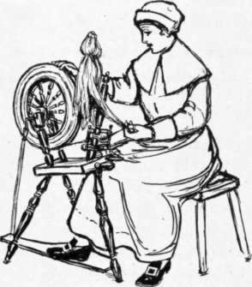
Fig. 111. - The flax wheel.
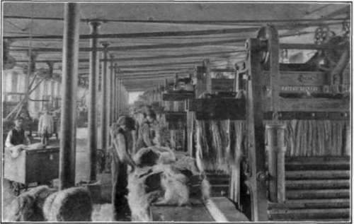
Courtesy of York St. Mills, Belfast.
Fig. 112. - Flax hackling done by machine.
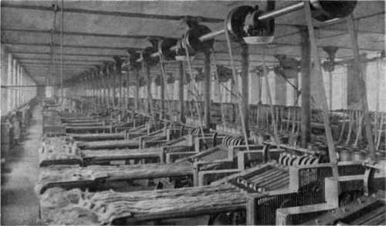
Courtesy of York St. Mills, Belfast. Fig. 113. - Spreading flax to make it a continuous line.
Weaving linen. After the threads of flax have been spun, they are wound on spools; and the spools are put in the big spool holder or skarn in order to prepare the roll of warp threads for the loom. Do you remember how the cotton warp was prepared and how the weaving was done? Uncle John says that in Scotland to-day much of the very fine linen is woven by hand; but we know that linen weaving by machinery has been perfected there and that very beautiful materials are produced on the modern looms with the Jacquard harness as it is called, to produce the wonderful designs. Fine table damask is as beautiful as fine silk. The French, perhaps, make the most beautiful designs for table linen, and the Scotch and Irish come next. (See page 124 for Jacquard loom.)
Bleaching linen cloth. Uncle John says there are many things to be done to the linen cloth after it is woven. If we were to go to Ireland, we might ride for miles and see the woven linen cloth spread on the grass in great lengths. This is called crofting or grass bleaching. Do you remember how we said grandmother used to bleach her linen? Did she use a chemical?
What did the sour milk which she used do to her linen?
What did the oxygen do? Chemicals are sometimes used to-day in the early stages before the linen is spread on the grass. Uncle John says that from 20-25 per cent, or about 1/4, of the weight of the linen is lost in bleaching. Linen is sometimes bleached in the thread, but more often after it is woven.
Finishing linen cloth for shipping. After linen cloth has been bleached, Uncle John says it is ready to be finished for shipping to the merchants. It is washed by passing the cloth through a machine called a rub-board. Then it is dried and passed through a beetling machine. This makes the fibers stand out. Then it is pressed between rollers to give it a smooth surface. Cotton is sometimes finished by means of these processes to look like linen and be sold for linen. When this cotton material is washed, the finishing wears off and it does not look like linen. Is such material cheaper or more expensive? Is it honest to sell cotton for linen, and to cheat the buyer? It is all right if the goods are labeled. Next lesson we shall talk about the buying of household linens. One must know many things in order to purchase wisely. Do you see how a knowledge of how things are made will help you, too?

Exercises And Problems
1. Write a story of two hundred words telling how flax is made into cloth.
2. Have an exhibit of articles brought from home, showing different patterns of linen cloth.
3. Perhaps there may be a cord factory near for you to visit. Tow is sometimes used in making twine. Study how cord is made.

Continue to:
- prev: Lesson 8. Learning To Wash And Iron Table Linen Or Bed Linen
- Table of Contents
- next: Lesson 10. A Talk About Buying Linens

