This section is from the book "Clothing And Health. An Elementary Textbook Of Home Making", by Helen Kinne. Also available from Amazon: Clothing And Health.

The Story Of How Silk Is Produced
Do you know that a tiny little worm gives us our silk dresses, hair ribbons, neckties, gloves, stockings, and many other useful things? Do you know how the worm makes the silk? It is a very wonderful story. Let us study about silk to-day.
In the picture (Fig. 63) you will see one of the silkworms full-grown. The mother and father were beautiful moths. The mother moth lays the little eggs on the leaves of the mulberry tree because they are good food for her baby worms. The sunshine and warmth hatch the little eggs. The eggs are like pin-heads, and are smaller than tiny grains of chopped corn which you feed your chickens. Your mother hen sets on the eggs until the warmth makes the chicks grow, but the sunshine starts the tiny moth eggs.
Soon a little baby worm comes out and is as small as a tiny thread. It grows and grows and eats and eats, until it is about three inches long and nearly as thick around as one of your fingers, as the picture shows (Fig. 63). It takes about a month for the worm to grow so large. It must be tended very carefully and given the right food, or it will die. The food must be chopped fine. It is like preparing milk for baby; is it not? They must, also, be kept very clean in order to grow. Cleanliness always helps animals, as well as people, to grow.
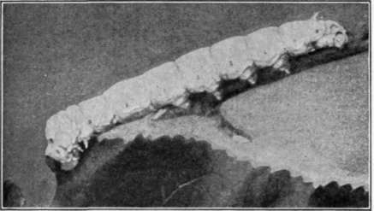
Courtesy of Corticelli Silk Co. Copyright, 1895, Nonotuck Silk Co. Fig. 63. - Corticelli silkworm, eating.
Have you heard that there are some countries where the silkworm grows better than in others? Can you name the countries producing the most silk? You have learned that in your geography. Yes, Japan and China and Italy. Yes, and France and Asia Minor, too. Do you think the United States produces very much silk? Why not? In the countries named, labor is not so expensive. Silkworms require much care and labor.
Silk is the most beautiful and the strongest of the common fibers. It also costs the most. The silk fiber produced by these tiny worms is often four thousand feet in length. Let us learn how the tiny worm does such a wonderful thing. He must work as hard as the busy bee.
After the worm is full-grown he begins his busy work. This is like boys and girls; they, too, begin to work when they are grown. If well fed and clean, the worm will work well. This is apt to be true of girls and boys, too. The worm begins by making a house for himself called a cocoon (Fig. 64). Have you ever seen the cocoons of any moth? If you will look, you will find them on the trees. Miss James has some cocoons of the lovely green Luna moth. She put the green worm in the box, and it has spun a cocoon. We do not find the mulberry worm growing wild in the United States. In some countries it grows wild, just as our Luna moth.
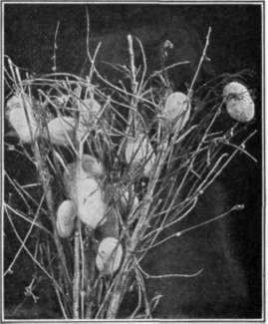
Courtesy of United States Department of Agriculture.
Fig. 64. - The houses or cocoons built by the worms in the branches.
When the worm is ready to spin, she throws out two tiny little threads one from each side of her head. This is a secretion and is a kind of jellylike fluid. As the air touches it, it hardens. She works her head back and forth, and the tiny filaments, or threads, as they are called, are joined together into one. She works and works until she has built a house of silk threads all glued together so that it seems like a mass of parchment paper. These houses are about 1 1/2 inches in length, and are white or yellow in color. In China and Japan these cocoons are grown and tended very carefully. The outside of the cocoon is covered with the loose fluffy silk which the worm uses to attach his home to a leaf or twig. It takes the worm three weeks to make this long, continuous thread called a cocoon. During that time a wonderful thing happens. The worm inside the cocoon is changed to a moth like her mother and father and is ready to leave her home by eating her way out. What would happen to the long silk thread if she did that? Yes, it would be broken into small pieces and not be one continuous piece. Some moths are permitted to come out (see Fig. 65). They then find a mate and soon more tiny eggs are laid by the mother moth; and all the story begins again.
A sad thing happens when cocoons are grown for the silk. The moths are not allowed to come out and break the thread; but are put in a very hot place so they die inside. The cocoons are then ready to be reeled or wound off. They are placed in basins of hot water because the gummy secretion of the worm must be softened. The ends from four or five cocoons are caught together and reeled, or wound, off together. This makes a strand of raw silk.
John Alden told the following story. He said his father read it aloud the night before when the family gathered about the big open fire. Once upon a time, long ago, people did not know how to use the beautiful fibers of the silkworm. We are told that a Chinese empress discovered how to use it as long ago as 2700 years before the birth of Christ. Every year, in April, the Chinese people have a celebration in her honor, because of her valuable discovery. Think of all the riches she added to her country because of this secret.
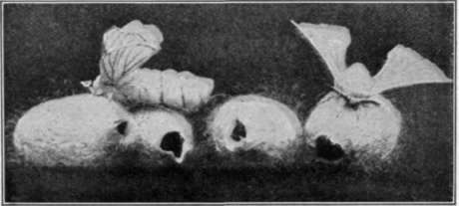
Courtesy of Corticelli Silk Co. Copyright, 1895, by Nonotuck Silk Co. Fig. 65. - Corticelli cocoons from which the moths have emerged.
It is said that for many years this secret was kept; but later some monks traveling east to India and Constantinople told others how to reel the silk fiber. Then the use of silk fiber spread to Greece and Italy and Spain, and by the fourteenth century was common in France. Since then, silk manufacture has grown rapidly in importance. John traced the journey on the map. Will you see if you can trace this journey of silk manufacture. Where do you think the secret was carried from France?
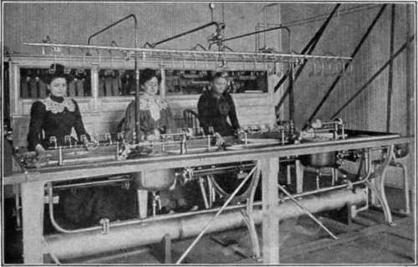
Courtesy of United States Department of Agriculture. Fig. 66. - Silk reeling. The cocoons are in the basins before the women.
Can you send for some cocoons and raw silk?
Your teacher will tell you where to write. Raw silk, as it is wound from cocoons, is made up into hanks like the worsted which you buy at the store. It is sold in hanks by the pound and costs from $7.00 to $10.00 a pound. It takes three thousand silkworms to spin a pound of raw silk. Do you know that for grandmother's dress about two pounds of raw silk were necessary? Can you tell how many worms were kept busy?
In another lesson we shall learn how the manufacturer of silk ribbons or silk material takes the raw silk and makes it into beautiful fabrics. Now we know about a useful little animal as well as about a plant which gives us clothing. Silk, however, is more expensive than cotton. Cotton is sometimes made to look like silk. The cotton fiber is mercerized, which means soaked in certain chemicals and stretched to make it look silky. Lisle thread looks somewhat like silk. It is cotton twisted hard to give it a luster. Another day we shall learn more about these.

Exercises And Problems
1. Do you know where silk is grown? Write a story of 100 words telling about it.
2. Why is not more silk grown in the United States ?
3. Find on your map of the world the principal countries where silk is grown.
4. Name some articles made of silk which you use every day; which you see used.
5. What are some of the other uses which we have for silk?

Continue to:
- prev: Chapter III. Learning To Make Some Attractive Gifts For Christmas Or For A Birthday Present
- Table of Contents
- next: Lesson 2. Simple Articles Easily Made From Silk Scraps

