We are about to make a dragster Buggy and to start the project need to define the BRIEF for the work we need to do. On the reverse side of this sheet is
the full list of design work we need to complete for the task.
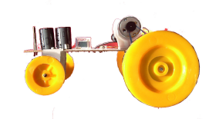

The Brief is an outline to, or an introduction of the task. It should state why you are making the toy. As a designer you will have been asked to create a new toy for a particular market and should therefore first of all check out several things:

- How much parents and children spend on toys,
- How long they expect them to last
- How much dependency they place on reliability of products they buy.
You could ask other questions of your own that would help in confirming that a market is really there. The results should be presented graphically using bar-charts, pie charts, etc.

You should check out existing toys that will compete with the toy you are going to make and products like ‘Mini-racers’ and ‘radio-controlled’ items might be included. Other ‘sensing’ toys could also be considered.

You will need to research suitable materials and manufacturing methods used to shape them. You should consider making toys in large numbers.

You will need to research power sources and components that will be used in the toy. As a designer you will be expected to roughly know how much the toy will cost to make.

You could research themes, colours, legal requirements for electronic toys and suitable circuits. All of this will need to be achieved in a time of about 40 hours and so your time should be spent wisely with homework and lessons used effectively. Wasted time cannot be found elsewhere – it will just lead to unnecessary pressure on you to complete your GCSE coursework.
WRd-October-2003

