MISCELLANEOUS BRITISH INVENTIONS:

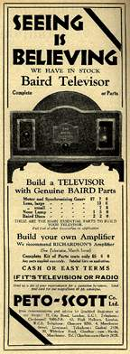
Henry Bessemer (1813 - 1898) took out a total of 117 patents: his name is immortalised in the Bessemer Converter, for producing steel, but he also invented many other things, amongst them the embossed stamp, cheap lead pencils, the spinning mortar shell and in 1869 an anti-seasickness device intended to stop ships from rolling in heavy seas. Unfortunately it also made them unsteerable and his prototype, the Bessemer, demolished the pier at Calais and was one of his rare failures.
The first sewing machine was patented by Thomas Saint in 1790, long after the knitting machine, invented by William Lee in 1589; in 1810 Peter Durand patented the food canning process (but the can OPENER was not invented until 1858, when Ezra J. Warner of Waterbury, Connecticut patented the first can opener for use by the U.S. military during the Civil War!)
John Logie Baird (1888 - 1946) is immortalised for his invention of Television (1926) but also worked on early developments in radar and fibre optics (1924/5).
Kirkpatrick MacMillan invented the pedal cycle 1839 (but failed to patent it!)
The world's first powered flight took place not in America in 1903, but at Chard in Somerset in 1848 by John Stringfellow with a flight of 10 yards.
Still in the field of transport, the first traffic light was installed outside the Houses of Parliament in 1868 to keep the large number of horse-drawn carriages in the area from colliding. Unfortunately, the gas-powered light blew up, killing a passing police officer and thus discouraging further experiments until 1926 when the first automatic traffic light was installed in Wolverhampton. (It remained in service until 1968.)

