Design & Technology

Name and Form:
Using the Pillar drill for the clock project.

Step 2.
Step 1.
Secure work.
Secure bit - remove key
Step 3.
Check safety before drilling....
Step 4.
Lower drill assembly carefully....
Step 5.
Turn off drill. Watch it, it's hot!!!
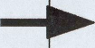

What did you use to firmly hold the clock face, or any components that needed drilling so that you could safely drill them?
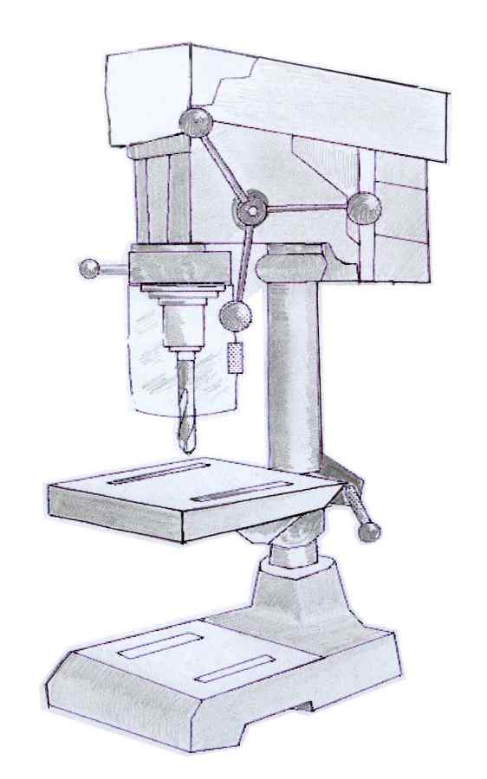
1. Using drawings and notes, explain how to drill holes using the Pillar Drill.
Use extra paper if needed
2. Using the key words listed below, label the picture of the Pillar drill.
3. Write down five pillar drill safety rules.
Drill bit
What did you use to select the correct size of drill bit before drilling ?
Five safety rules.
Pillar
1
2
3
Pulley gear casing
4
Chuck
Table
5
Handle
Guard
www.design-technology.info Design & Technology On The Web

